Pcaap poisoning

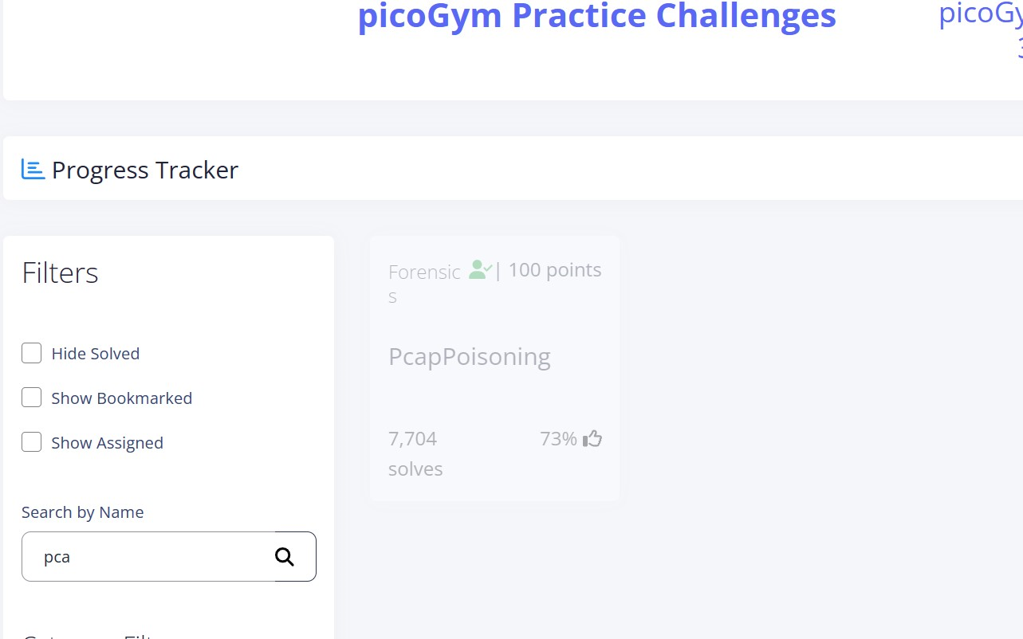

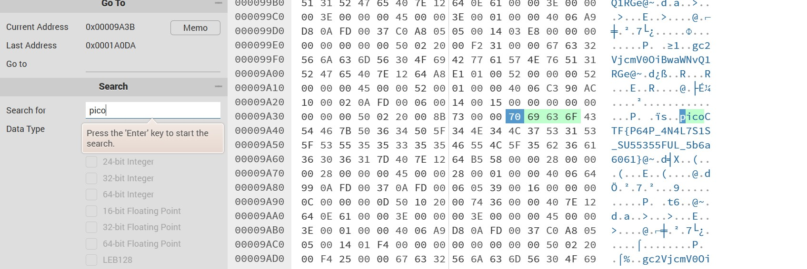

I inputted the file into hexeditor and got the flag.

File type